**Microsoft Azure Virtual Training Day: Azure Fundamentals Day 2**

Online free training from MS 16/09/2021

Contents

Resources 2

Introduction – Day2 3

Module 4 - Azure Security and Network Security 3

Network Layer 4

Perimeter Level 5

Module 5 - Identity, governance, privacy and compliance 6

Core Identity Services 7

Governance 9

Tags 13

Azure Policy 15

Azure Blueprints 17

Cloud Adoption Framework 17

Security, Privacy and Compliance in Governance 18

Separate Azure Regional Offerings 20

Module 6 - Azure Pricing and Lifestyle 21

6 Factors Affecting Cost 22

Pricing Calculator 23

Total Cost of Ownership 26

Azure Cost Manager 26

Azure SLAs 27

Preview & Freeview 28

# Resources

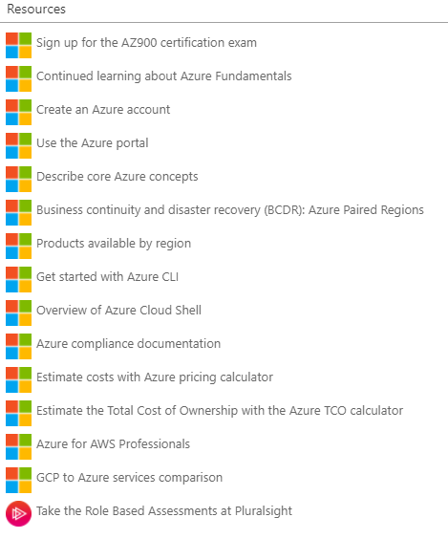

Info

**Welcome!**

Hello everyone! Thank you for joining the Azure Fundamentals Training day today. There is a list of resources available on your screen now. Please feel free to ask the live moderator questions within this chat box. If you are having technical issues, please click the question mark, Help widget on your screen now. Please do keep an eye on the Microsoft UK Training Days webpage for more events coming up <https://www.microsoft.com/en-gb/events/training-days>/ . Enjoy the session! – 'The Microsoft Training Days' Event Team

**Exam Information**

Once you have completed all of this training you are eligible to take the AZ-900 certification exam at no cost. You will receive a 'Thank You' email in the next 5 working days with steps on how you can claim and schedule your exam. You have 90 days from after the session to schedule the exam. The exam will be online and you will have 40-60 multiple questions with 60 minutes to complete. You have one attempt to pass the exam for free, after this there will be a cost of $99 but we are sure you will pass first time! There are no official Microsoft practice exams. There are several paid options available through LinkedIn Learning, Measure Up, and a number of other providers. However, we recommend that you check out the knowledge checks at the end of each of the modules in the learning path which is the first link in your resources box. Good Luck!

**Agenda**

10.00 – 10.03​ Introduction​ 10.03 – 11.20​ Azure Security and Network Security​ Identity, governance, privacy and compliance​ 11.20 – 11.30​ Break-10 minutes​ 11.30 – 12.00​ Azure Pricing and Lifestyle​ 12.00 – 12.30​ Closing Q&A​

Info pack with all content here: 

# Introduction – Day2

Exam – 60 mins multi-choice

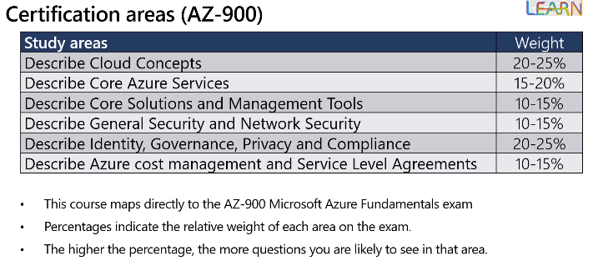

# Module 4 - Azure Security and Network Security

Missed 1st 20 mins which included key vault!

Layered approach to security – from data centre to azure services with data as final layer

So even if 1 layer breached you have the other layers to protect.

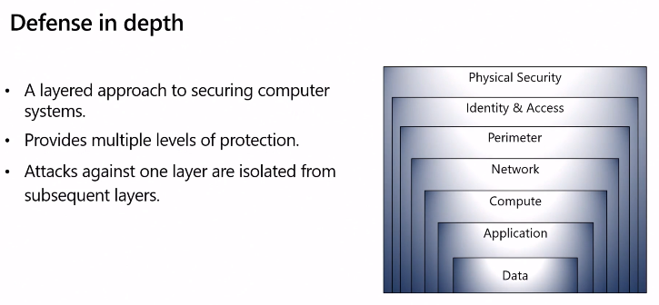

Who is responsible for the security – you or MS?

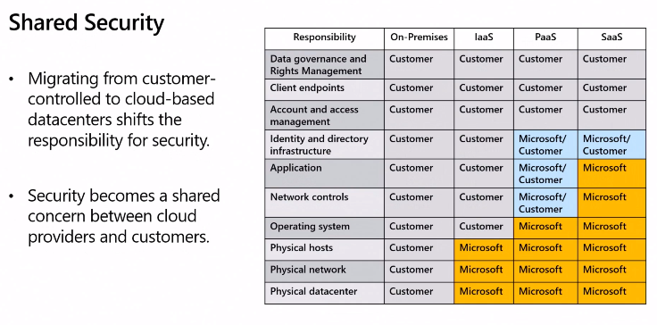

For IaaS MS only infrastructure you need to do config and secure that and everything else

PaaS MS underlying OS but share network, identity, infr, etc

SaaS youa re still responsible for Data, end points, accounts and account management

## Network Layer

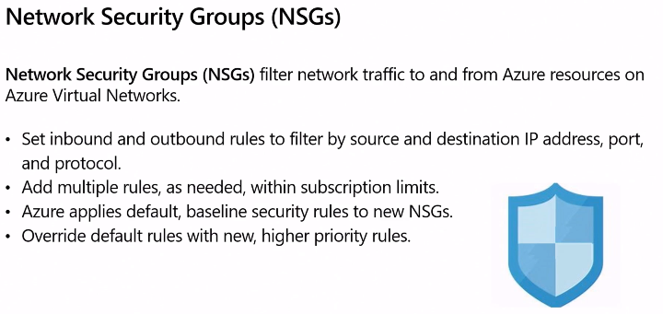

Traffic already on your network – inbound and outbound rules – multiple

Some already auto configured, you add mor as needed.

Cannot delete rules but can override them

In the portal

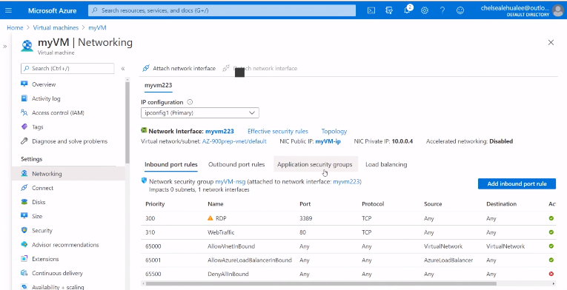

Network security group was auto created with VM creation

Can chose to add or remove

Opened up RDP with higher priority rule so it over-rights others

## Perimeter Level

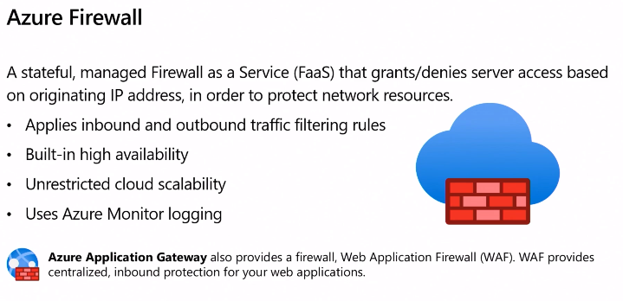

Inbound/outbound – https protocols, remote desktop, all ports, application level protection

Firewall – 1st line support

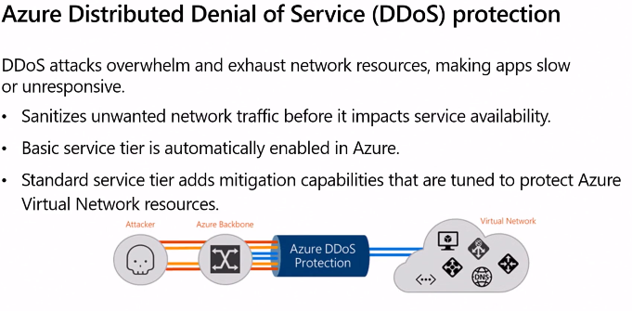

DDoS attack overwhelming amount of traffic to azure network and/or services

Perimeter traffic is it allowed call

DDoS protection – is this valid traffic!

Standard service is additional cost – specific to Azure resources – only use on business critical applications.

Most find basic tier is fine.

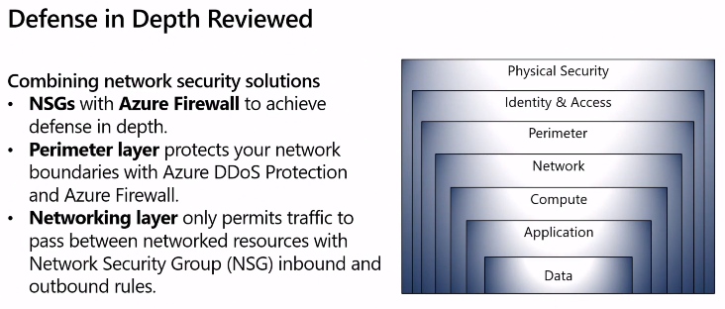

Multi-layer, multi-vector security – deep and complex.

Ongoing as changes daily.

# Module 5 - Identity, governance, privacy and compliance

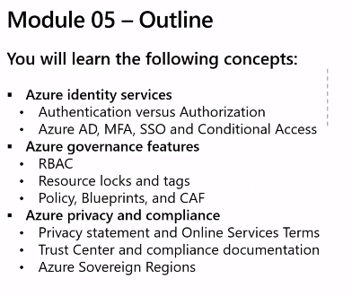

## Core Identity Services

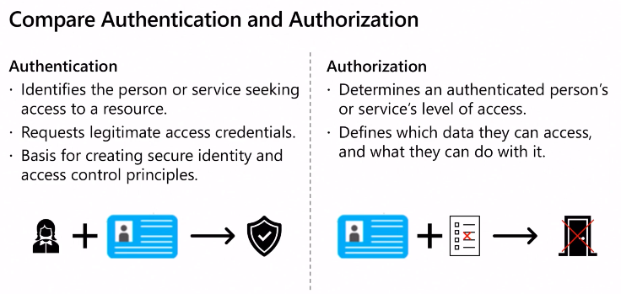

Authentication = Identity - The person is who they say they are

Authorisation = what you have access to – where go/do

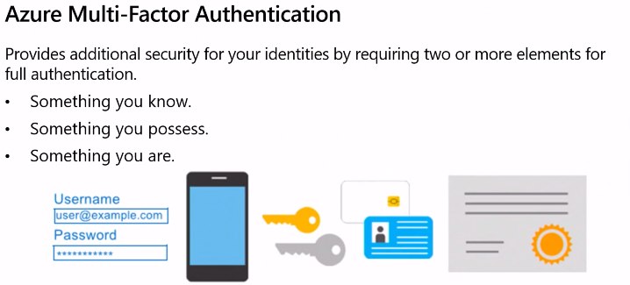

Another layer of identity authentication

Finger scan, code, token generation device, face scan, etc

No biometric properties at the moment.

Azure Active Directory (AAD)

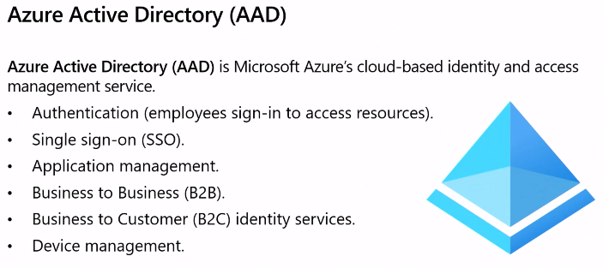

Does not replace company AD but can use with AD

Cloud based AD – self serve password reset, MFA, etc

SSO – 1 user/pass for everything, easier for admin – changes/leavers – 1 change

Can chose to use AAD MyApps portal cloud or on-premise applications

B2B & B2C get to control these – how they sign-up, access, etc

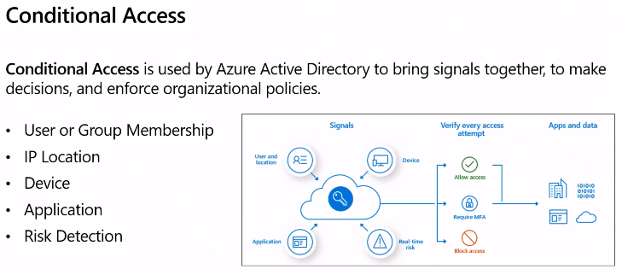

Allows control who, where, groups, etc can log in

If then else statements

e.g. if corporate device, corporate network then allow access

if corporate device, non corporate network then MFA required

if not corporate device, not corporate network then no access

## Governance

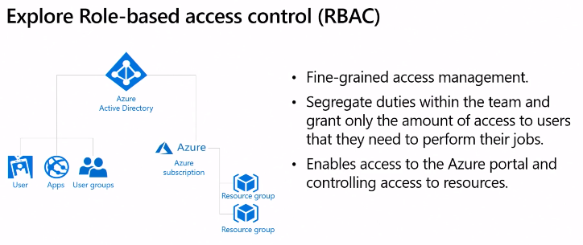

No additional price for this module

Admin User can only manage single subscription

DBA – all databases in a single subscription

Limit access only what required to do your job

RBAC in the Portal

Can apply at different levels – demo uses subscription level

Can do subscription group level, individual level

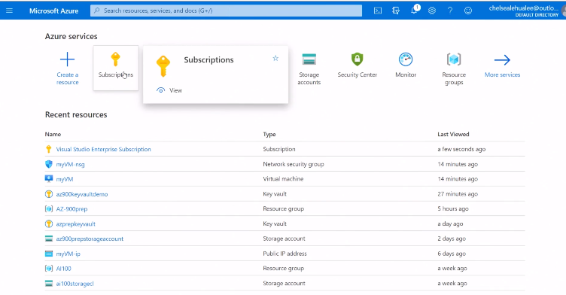

Can add different roles – different roles built in

Can create own roles.

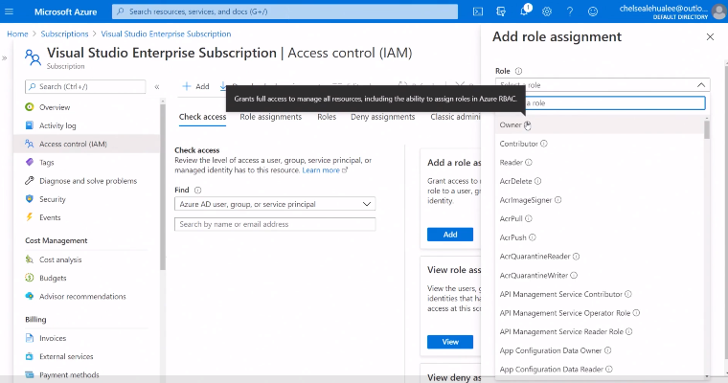

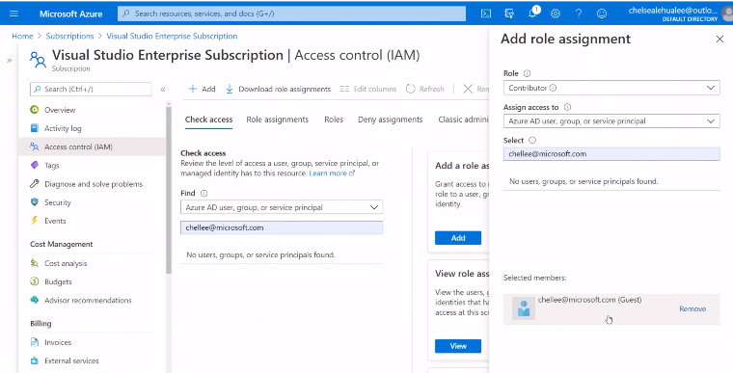

Sends email to the input email address

Can change/revoke roles

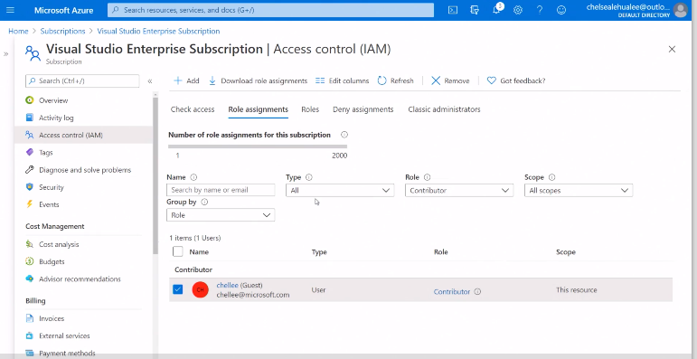

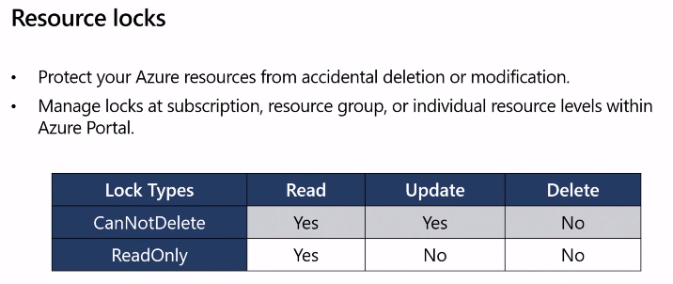

Accidental deletions cannot get it back!

So protects by resource locks

Also have ReadOnly locks

Access permissions required to do this!

In Portal

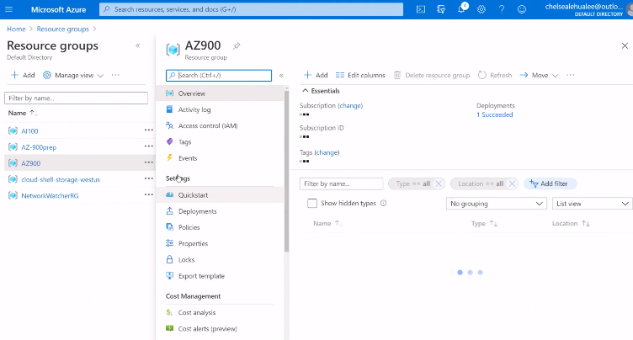

Button at the bottom to add locks

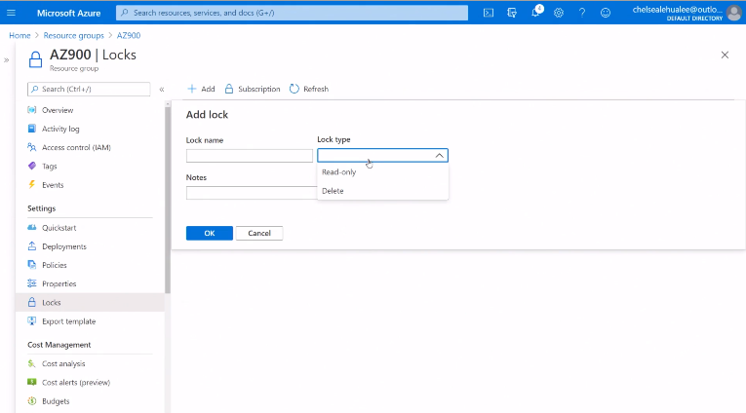

Parent/child relationship hierarchical

So if apply at resource group level then applies to everything in that resource group. Similarly if subscription level then applies to all resource groups below.

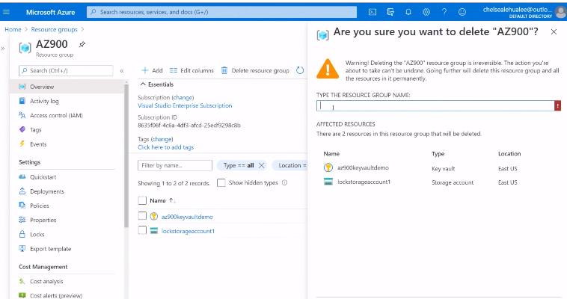

Big warning and makes you type the name

Does not let you delete as there is a delete group on

Read only lock does not let you create new resources/storage account in subscription and does not let you delete

## Tags

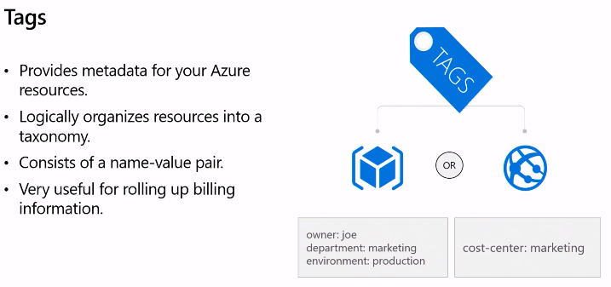

Adding meta data to resources – not got parent/child

If you use templates can auto add in the tags (json files)

Good for splitting subscription into dept/cost centres and giving view on who is using what.

Organising resources via tags

Up to 50 tags per resource

In Portal

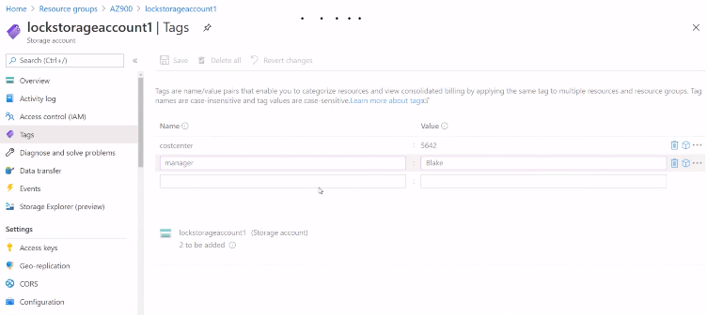

## Azure Policy

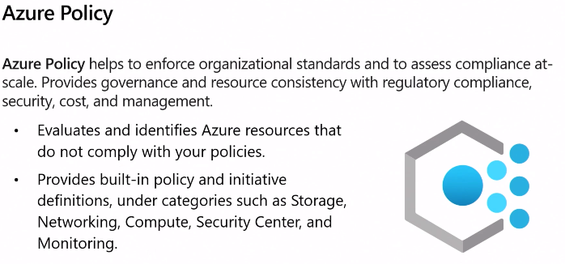

Enforce only certain level of VM

Storage account skew

Set only certain regions

Only certain people can build VM

Number pre-built policies

Can chose level of Policy – subscription, resource groups, etc and applies to all children

In Portal

Search bar to find

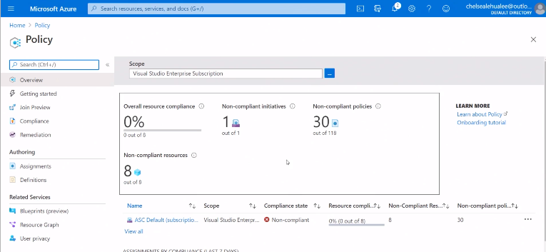

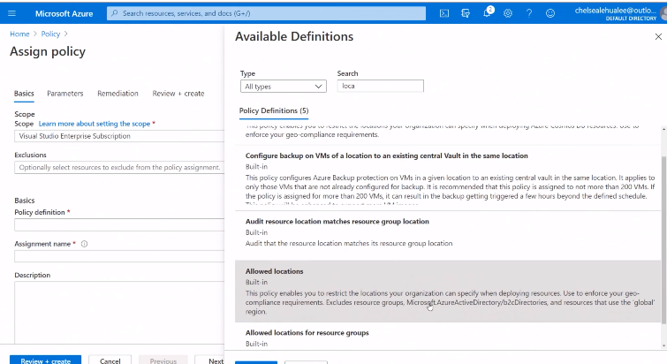

Compliance check will not stop existing resources but will mark them out of compliance (after an hour or so – need time to sync up)

Any new resources will not be allowed unless they meet the new policy rule

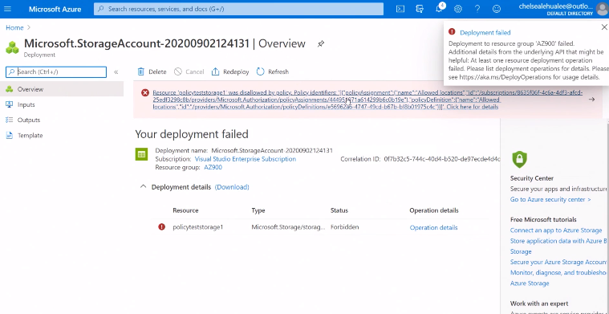

Auto manage Azure environment on rules you set up

## Azure Blueprints

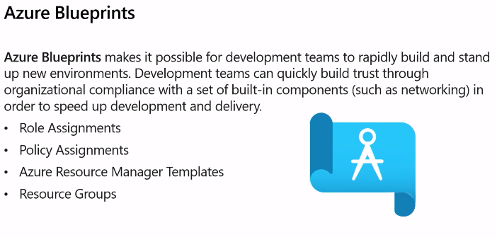

Quick for spinning up test and other environments

Orchestrate setup of environments

Unlike ARM it also tracks once released - auto and track capabilities of environments

## Cloud Adoption Framework

Good for those new to Azure and Cloud

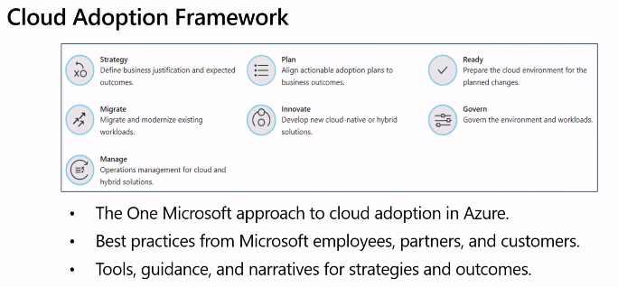

Help you go through everything you need to setup your Azure environment

## Security, Privacy and Compliance in Governance

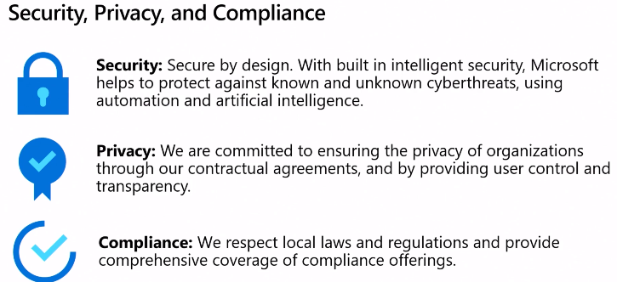

Transparency & Trust

1. How compliant is the cloud supplier when handling sensitive data
2. How compliant are cloud providers
3. How can you create apps and ensure they are compliant

Trust Centre shows you all this

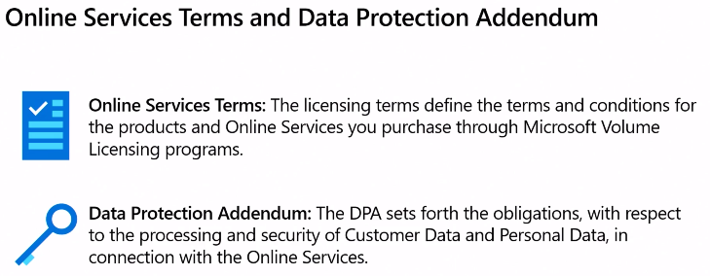 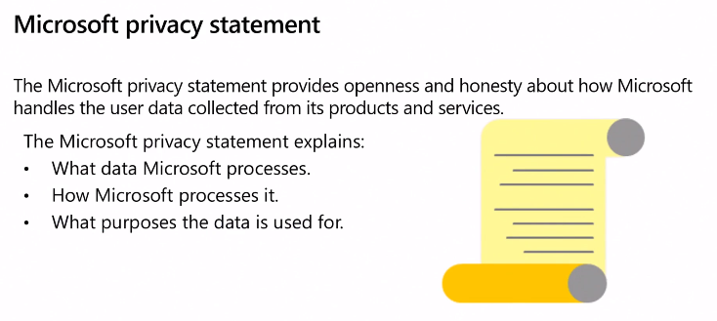

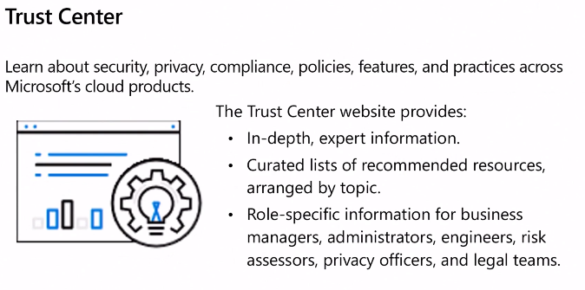

In Portal

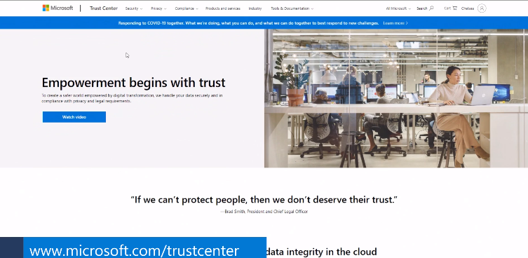

**Pick from menu options at the top**

e.g. Click Compliance to see all offerings

Click Compliance

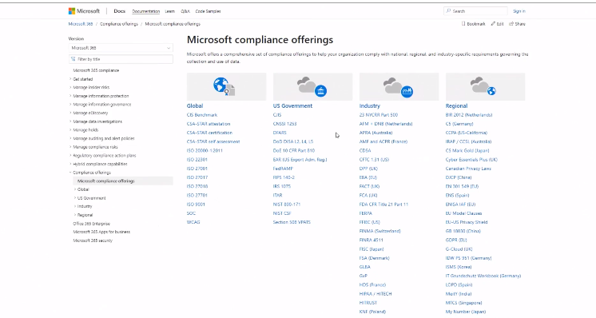

Not every service offers every compliance e.g. us government compliance not for non us

## Separate Azure Regional Offerings

2 separate offerings – data centres and all – physically separated from all other Azure

Can only access if you have authority

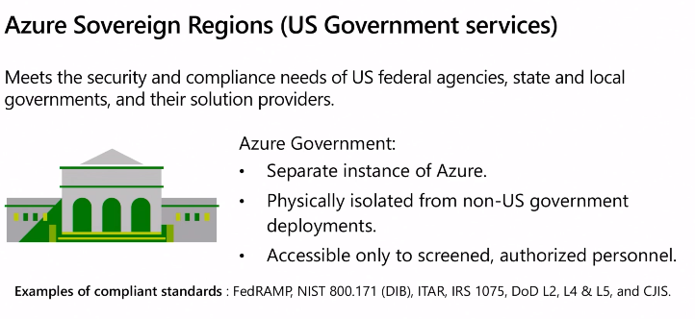

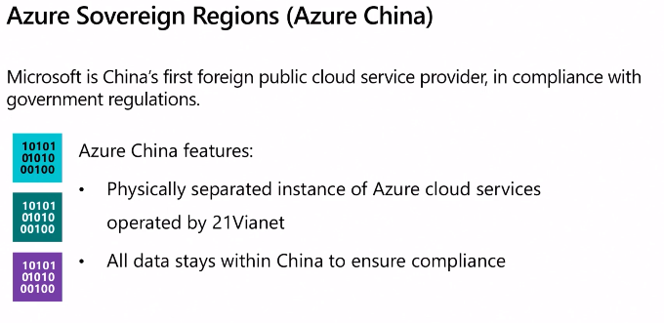

# Module 6 - Azure Pricing and Lifestyle

This is on the AZ900 exam!

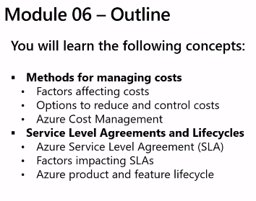

## 6 Factors Affecting Cost

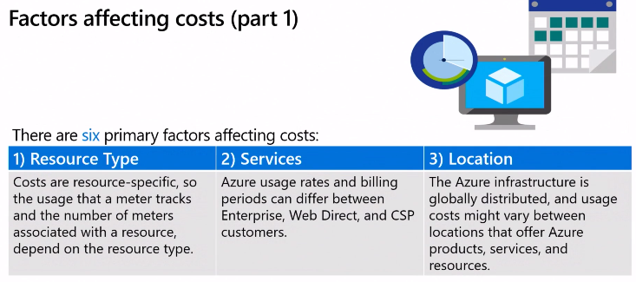

Main 6 drivers of cost

**Resource Type**

Resource and meter to track how much used

VM, Storage account, dbase, etc

**Service**

Web Signup and become a customer – full retail pricing, consumption based billing - monthly

Enterprise – sign up and agree minimum contract – annual basis billing

Cloud Provider – work with cloud solution provider – billing through them

**Location**

Every country/region has different costs – some are lower cost then others so if can locate in lower cost area do!

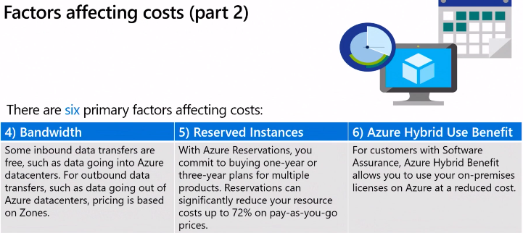

**Bandwidth**

If resources in/out are different regions that will incur charges. Try to pick region that means not got traffic in/out region billing zone.

**Reserved Instances**

Save money by committing to 1 or 3 year plans can be big savings e.g. 70%

Can downgrade for min fee if things change

**Hybrid**

?

## Pricing Calculator

Estimate not official invoice

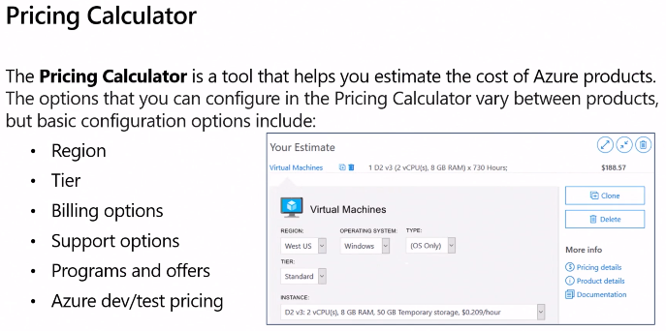

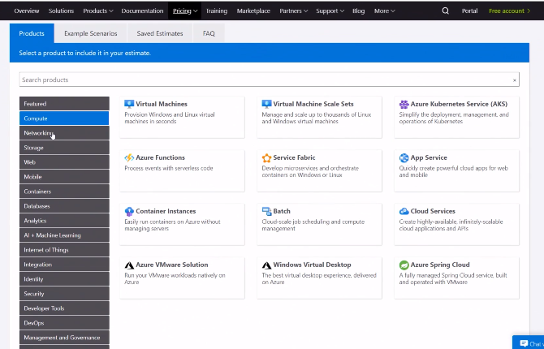

VM example

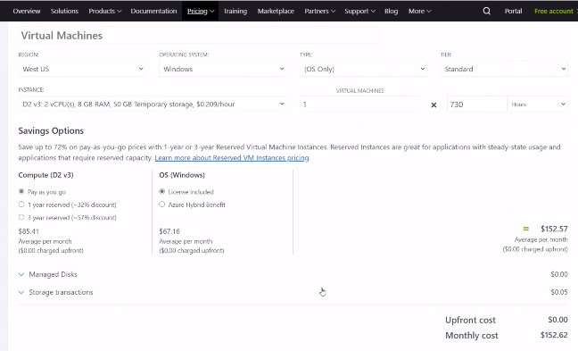

Default will fill in – can change

Change to East US

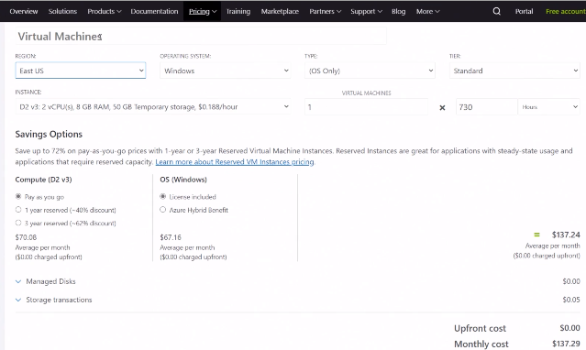

In VM can change operating system (Window = Hybrid as can use your on-prem Windows license) and also Tier. For Production need Standard. Others MS can take offline if need resources!

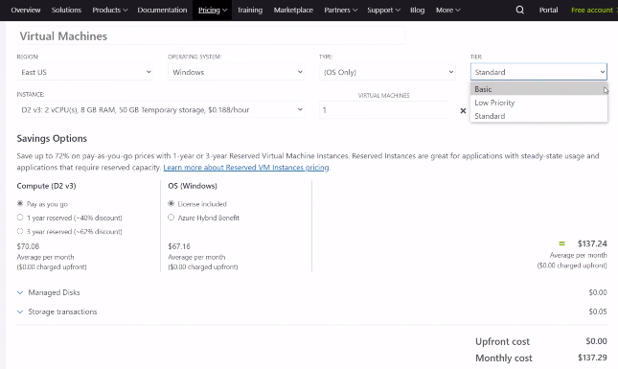

Add other resources e.g. storage account

Can save estimate to excel to share

## Total Cost of Ownership

Can use this tool to compare Azure and On-prem

MUST have all costs (e.g. rent, etc) for it to work!

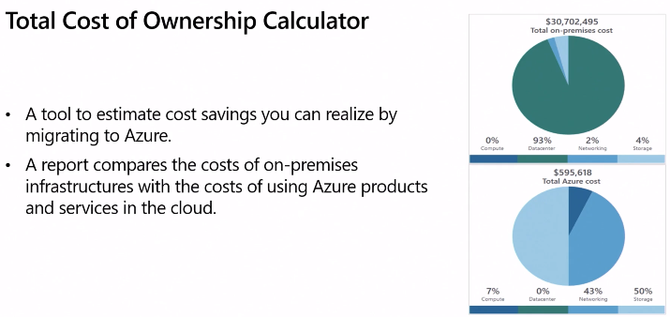

## Azure Cost Manager

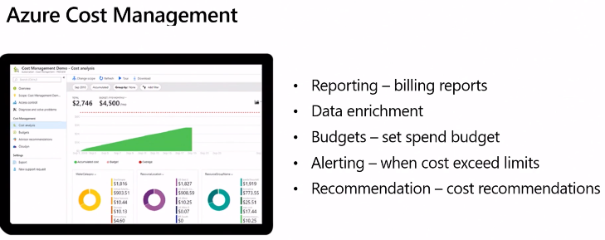

Can look at all billing reports.

If used Tags then can drill down deeper – subscriptions, resources, cost centres, managers etc

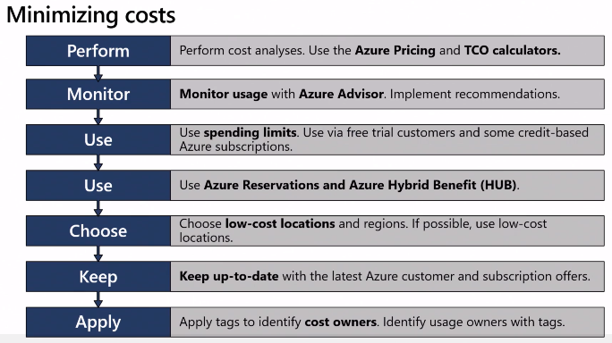

Set access so limit who can incur costs

Monitor and get alerts – based on tags as well

## Azure SLAs

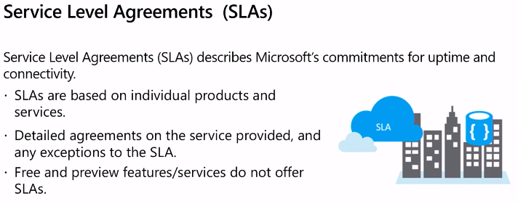

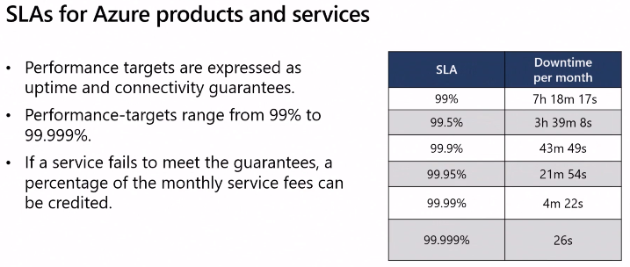

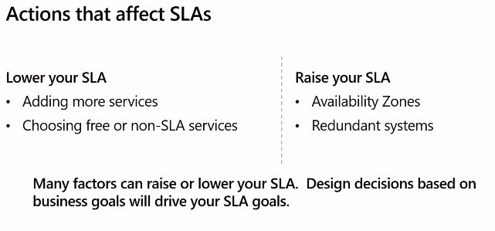

More services complicates SLA so SLA calculated as multiple of fractions for services and SLA!

## Preview & Freeview

Do not have SLA

DO NOT use for preview production as they are test services and no guarantee will make to general release and may disappear!

Good to see features to come – feedback and bug testing

